Student
Technology Handbook

A Guide To Online Learning

We have designed this guide for students who will be learning from home. This guide is written for parents to assist students when necessary, but will also be useful for students. Students that are attending school will also be using the same platforms and completing the same learning tasks.
Coleambally Central School will make an effort to ensure all students have access to technology during this current period. When students are using DoE technology and platforms they are reminded at all times that they are to comply with the NSW DoE Student Use of Digital Devices and Online Services guidelines. These can be found at:
https://policies.education.nsw.gov.au/policy-library/policies/pd-2020-0471?refid=285859

Coleambally Central School will be utlising a blend of six key software platforms that students will need to become familiar with, depending on stage, faculty and/or subject requirements.

  - The DoE Student Portal (K-12)
  - Microsoft Office (K-12)
  - Zoom (K-12)
  - Seesaw (K-2)
  - NSW DoE K-6 Online Guided Learning packages
  - Google Classroom (K-12)
Secondary students should already be familiar with Google Classroom, but will need to develop their ability to navigate and interact with Zoom. Primary students may/will have to become familiar with Zoom, Google Classroom (3-6) and Seesaw (K-2). This guide will provide a step-by-step guide on how to access our learning platforms as well as some tips and instructions of how to use different features on the platform.
Links to the NSW DoE K-6 Online Guided Learning packages will be provided directly to students and their families.

This guide will be developed more in the future and is a work in progess. Online learning is a new experience for both teachers and students. We appreciate any feedback from parents, students and our broader school community. Any questions about this process can be answered with a phone call. Please don’t hestitate to call.

TECHNOLOGY ON LOAN - DO NOT
- Alter any settings
- Change backgrounds
- Change the passcode in a CCS iPad
- Install any ‘apps’or software on DoE/school technology
- Take photos, images or videos on iPads unless as a learning activity directed by the teacher (The settings require iPads to be linked to a school account and all images taken may be shared to devices. These will be checked and deleted as required)
- Share your login/password
- Share a Zoom Meeting ID and password
- Let anyone other than CCS students use loan devices
- Access inappropriate material

Timothy Allen
Principal
20/08/2021

Content
- Logging on to a CCS Loan Laptop ……………………………….…………….………3
- Logging on to a CCS Loan iPad ……………………………………….…………..……3
- Student’s families sharing devices ………………………………….…………..……4
- Logging onto the Student Portal…………………………………….…………………5
- G Suite for Education…………………………………………………….……….…………6
- Microsoft Office 365…………………………………………..……….……………………7
- DoE Guide to Zoom……………………………………………………….………….………8
- CCS Guide to Conferencing with Zoom……………………..….……..……………9
- CCS Etiquette when Conferencing with Zoom……………..….……..……….10
- Signing in to Seesaw……………….……………………………..…….…….……………11
- Example of K-2 Student Login Details to Seesaw………………………………13
- Connecting an I Pad to Wi-Fi……………………………………….………………..…14

1. Logging onto a CCS Laptop

- Turn on your device
- Hold down Ctrl+Alt+Delete
- Press the Enter key
- Enter your username followed
by @detnsw
for example bill.smith5@detnsw
- Enter your password

PLEASE NOTE – If you change your student password, you will still need to use your old password to log onto a CCS computer. You will need to use your new password to access the portal
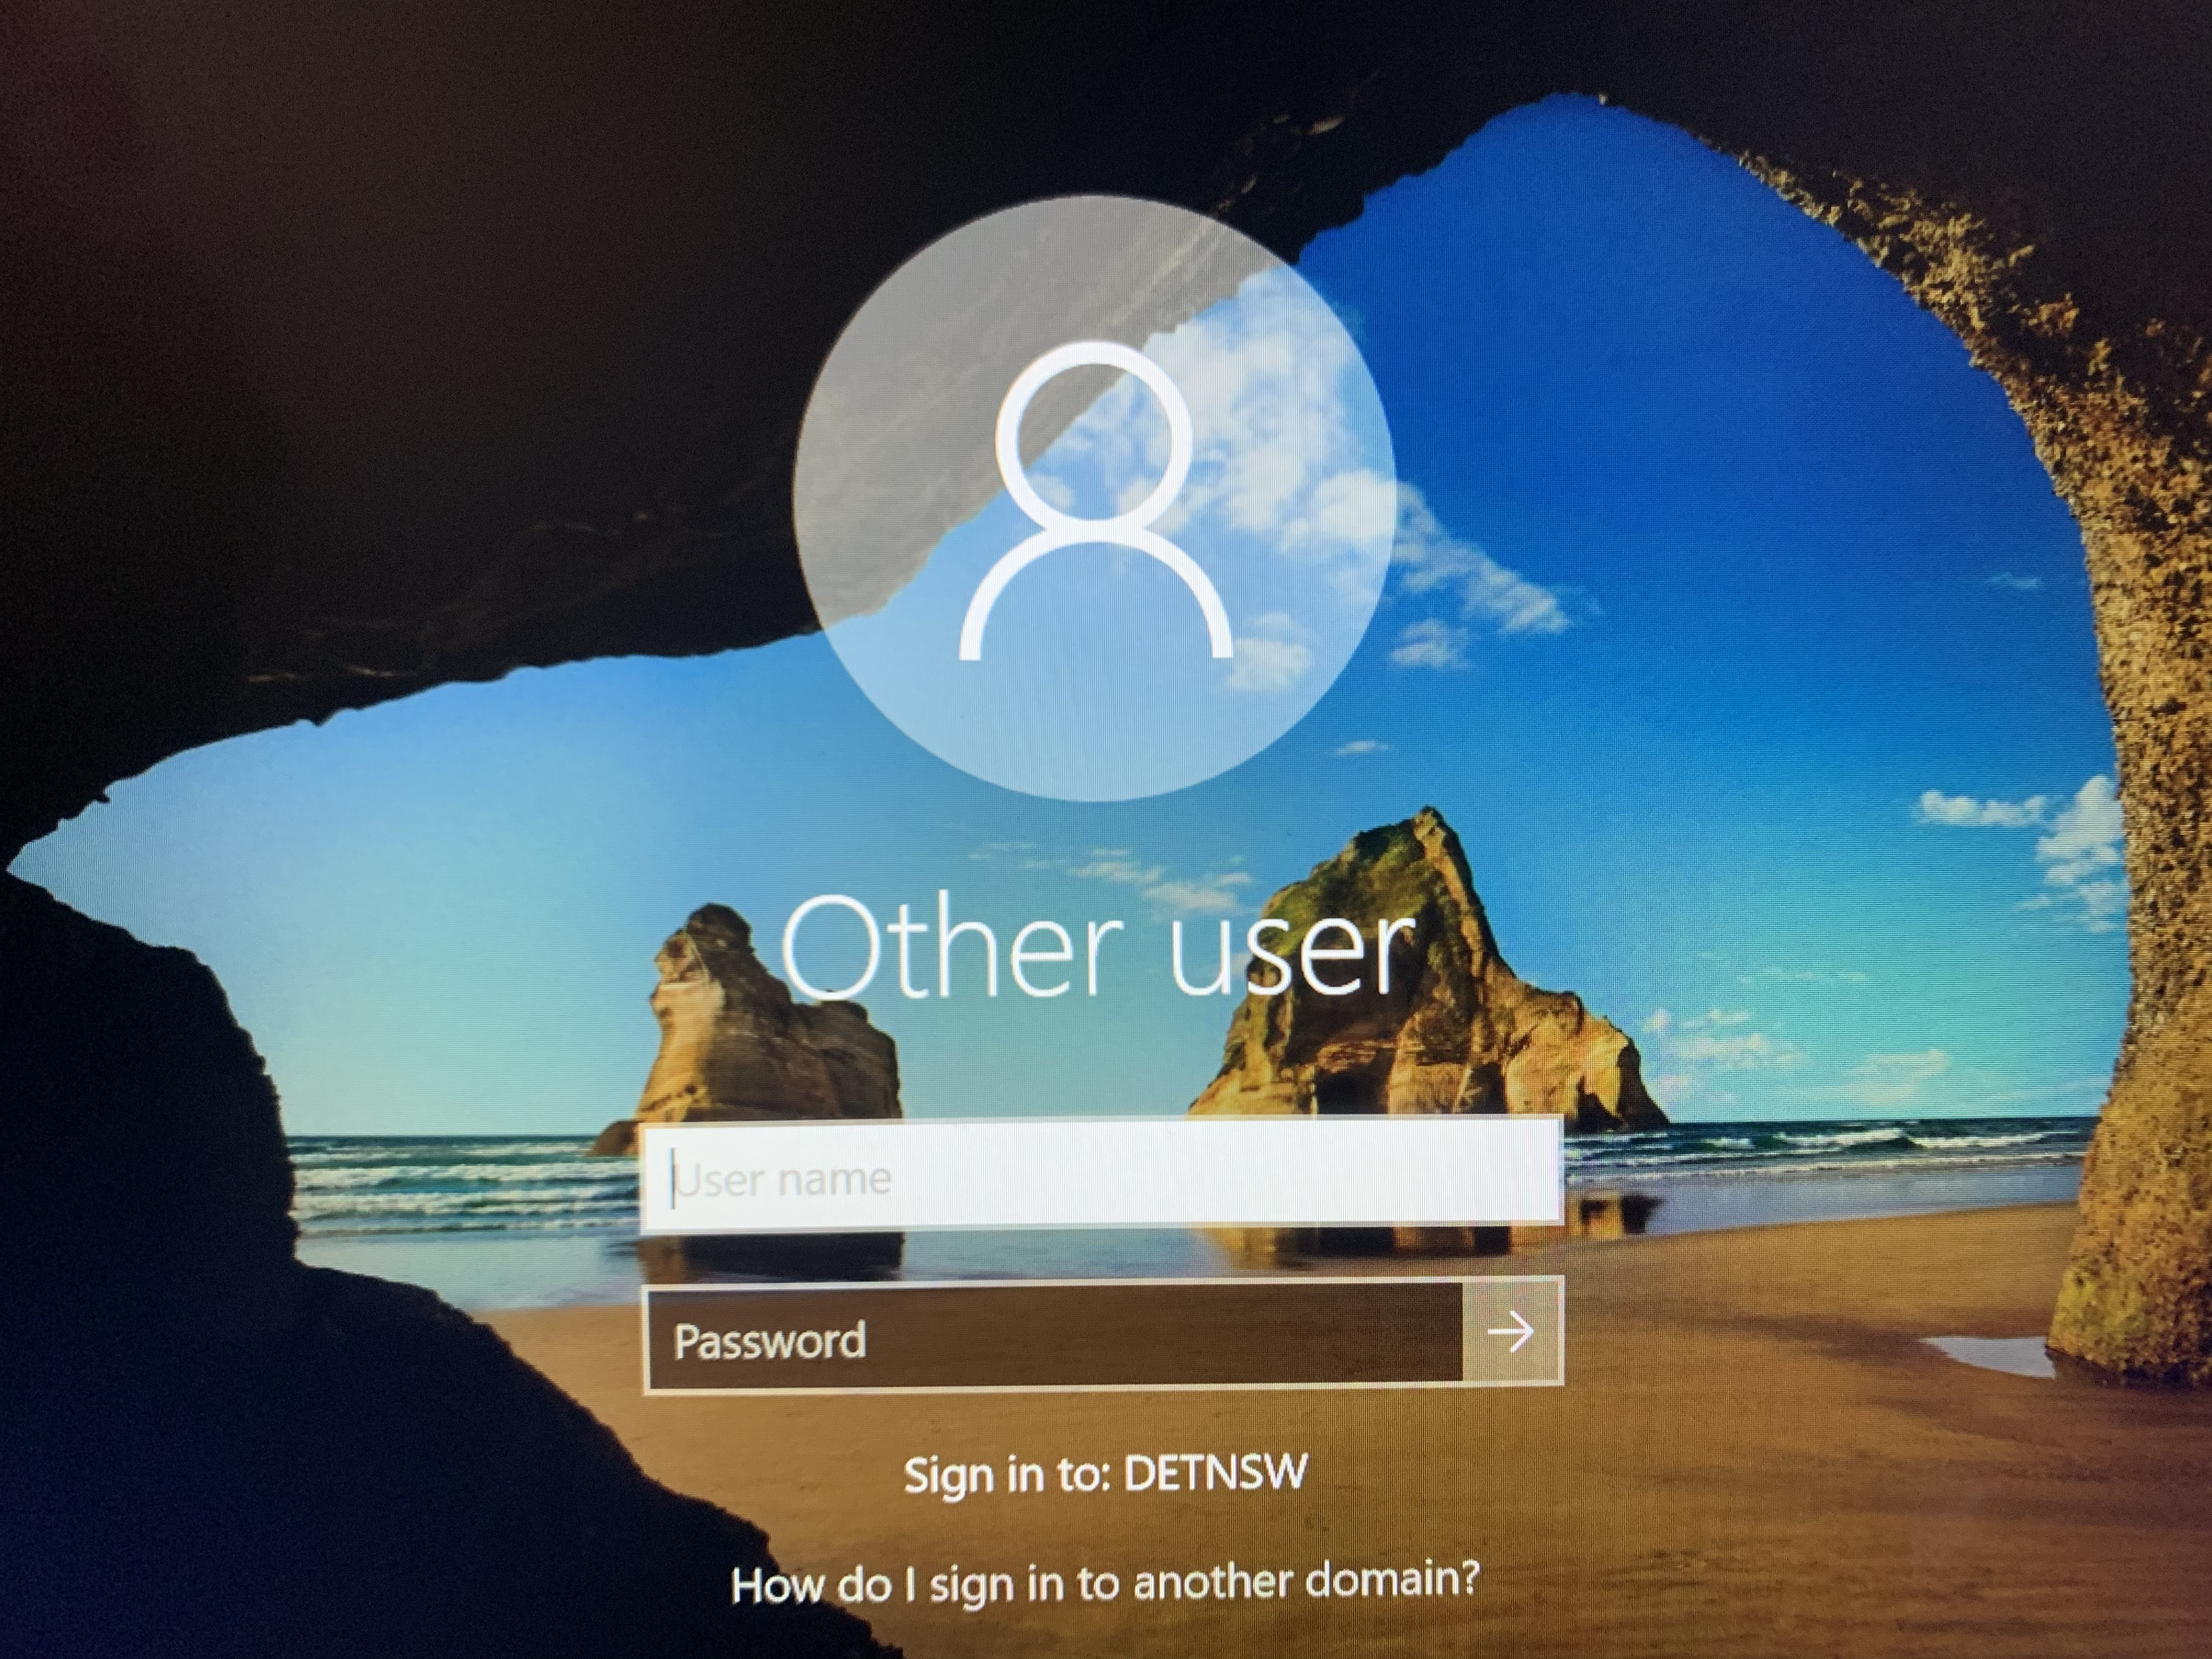

bill.smith5@detnsw

2. Logging onto a CCS iPad

Turn on your device
Press ‘Home’ button
Home screen should open
IF NO HOME SCREEN IS DISPLAYED
AND PASSCODE IS REQUESTED
Passcode will display
Press 123456

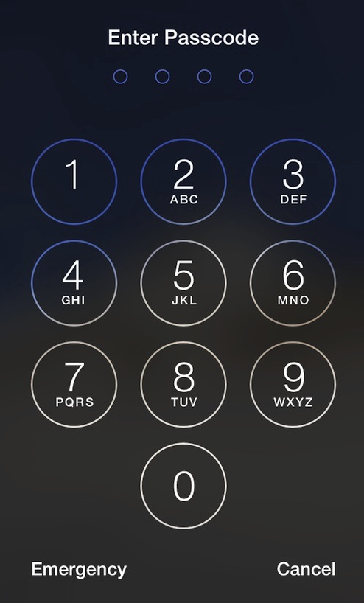

Press 123456

3. Student and Families Sharing Devices

It is very important for students and families that share CCS, DoE and home computers that they understand that if siblings are sharing a device (even their parent’s computer) they will need to switch between accounts and logins. If this is not done, and they do not sign out of everything or switch users, they will not be able to access the right Student Portal, Google Classroom or Zoom conference.
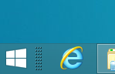

This can be done by following these steps:
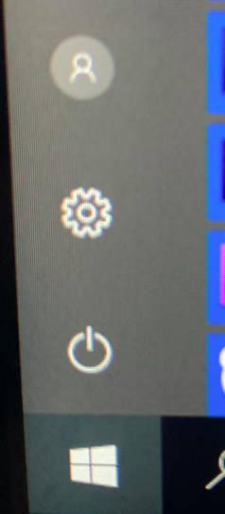

With the Student portal open

Click on the ‘Windows’ icon in the bottom left hand corner

Click on the little ‘Person’ icon that appears above

Click on ’Sign out’ in the menu that appears

The device is now ready for the next student to log into the Student Portal

Log is as normal (see next page)

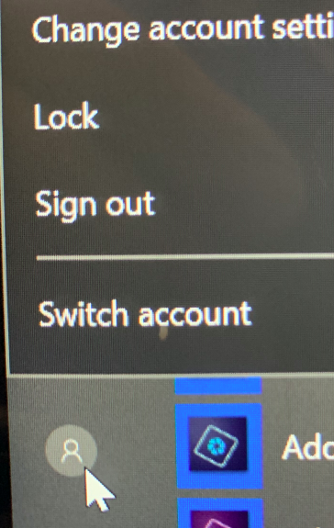

This process should allow students to access their portal and correct Google Classroom and Zoom conferences.

Google G Suite – Including Google Classroom

There have been difficulties with some students not being able to access G Suite (including Google Classroom) on their device. This usually happens when someone has logged into Google using a personal Google account.
Click here

If this is the case then the student needs to:

- Click on the logo in the top right hand corner of the Google screen (this differs depending on the avatar used)
- This opens up a window
- Click on ‘Sign out’
- Sign back in through the Student Portal
Or
- Use your student education email account to sign in
username + @education.nsw.gov.au

Follow prompts if needed

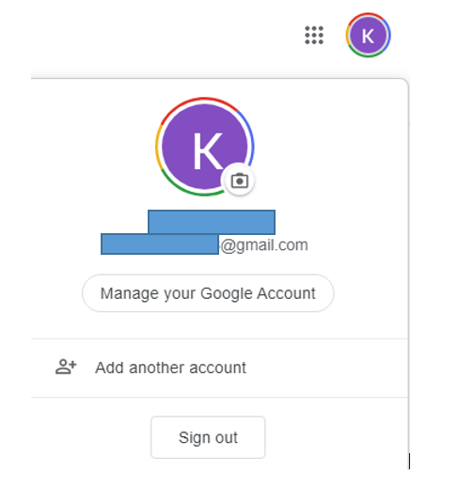

Click here

4. Logging onto the Student Portal

Open Google Chrome, Safari, Internet explorer, Firefox or Edge (whichever internet platform you have on your device). If possible, we encourage you to use a computer or laptop.

Go to the Department of Education website: https://education.nsw.gov.au/

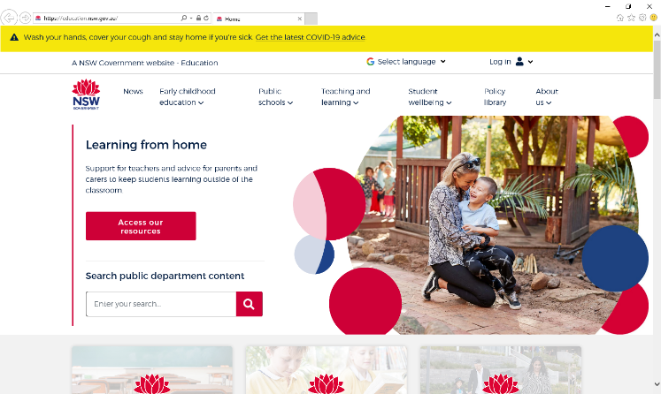

In the top right hand corner, click ‘Log in’.

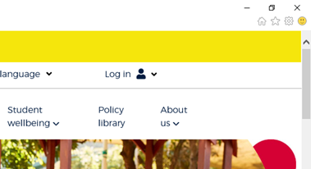

4. A drop box will appear and you will need to click ‘Student Portal’

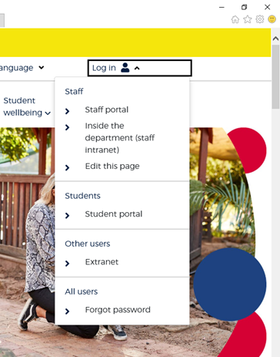

You will be then taken to the student portal to login. Students are to use their same login and password that they use on a computer at school. All students should know their login information, if not please contact the school.

Enter your User ID and password in the fields provided
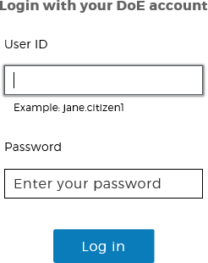

ie – bill.smith5

ilovedogs

- You are now in the portal. The portal page looks like the image below:
    - Access or send an email (1)
    - Expand the Learning component (2) by ‘Show more’ (3)
    - Approximately 10-12 options will appear, including ‘Microsoft Office 365’ and ‘G Suite’
    - Access both Microsoft Office 365 and G Suite (Google Apps for Education)
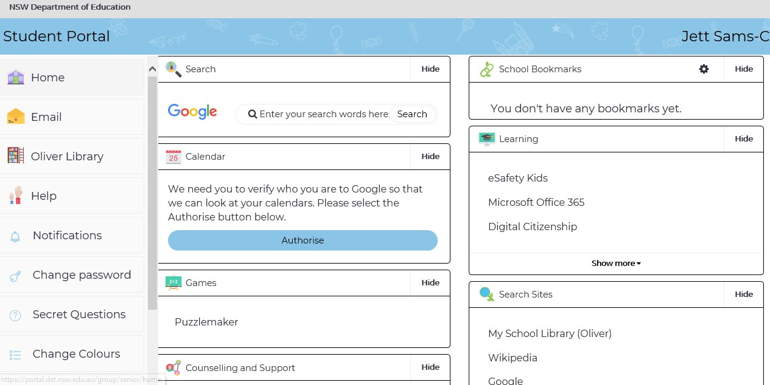
(1)
(2)
Office 365
(3)
Find G Suite by clicking
on ‘Show more’
Harry Potter
Your email account is your username plus @education.nsw.gov.au
e.g. bill.smith5@education.nsw.gov.au

G Suite for Education
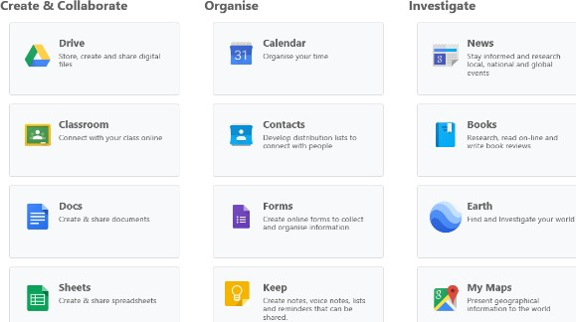
  - Access G Suite (See point 7 above).
  - Students have access to Google Classroom, Docs etc. and are able to store their work in Google Drive.
  - Students can easily collaborate and share G Suite items.
  - G Suite apps can be put on a mobile device.

Microsoft Office 365
Once Microsoft Office 365 has been selected (see previous Point 7) the student will see:
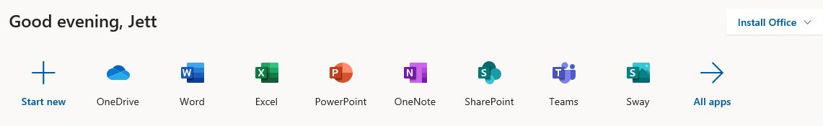
Harry

Students can use any of these applications and access their work by returning to Office through the student portal. All work created will be saved in the student’s OneDrive account (online). Therefore, work is not saved on your device, it is saved ’in the cloud’ and accessible from any device with an internet connection.
Tip! Did you know DoE users can install Microsoft Office from two different sources?

Source 1: On the Hub
The On the Hub version of Office is free for students. Students receive an activation code which does not expire – however under the licence terms you
must cease to use it when you leave NSW Public Education. The current version available is Office 2019. Using this version means you do not need to sign in to use it. Please note: It can only be installed on one computer. Once installed, you are working ‘offline’ – not using the internet.

Source 2: DoE Office 365 Portal
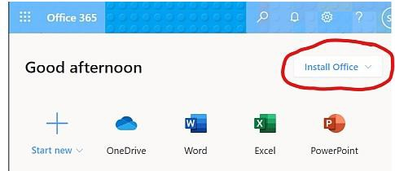

When logged onto Microsoft Office through the student portal (as in the step above), the Install Office feature (as shown above), allows the DoE user to obtain a free desktop copy of Office. This is tied to your DoE user account and needs to be signed into to stay licenced. Therefore, when you leave school and lose your DoE account, it will stop working and you will lose access to all your documents in OneDrive. You can install this on up to 5 Windows and/or Mac devices and this version of Office will update to the latest available automatically.

Need some help on how to use Office 365? Go to:
https://support.office.com/en-us/article/office-quick-starts-25f909da-3e76-443d-94f4-6cdf7dedc51e

Or Click here
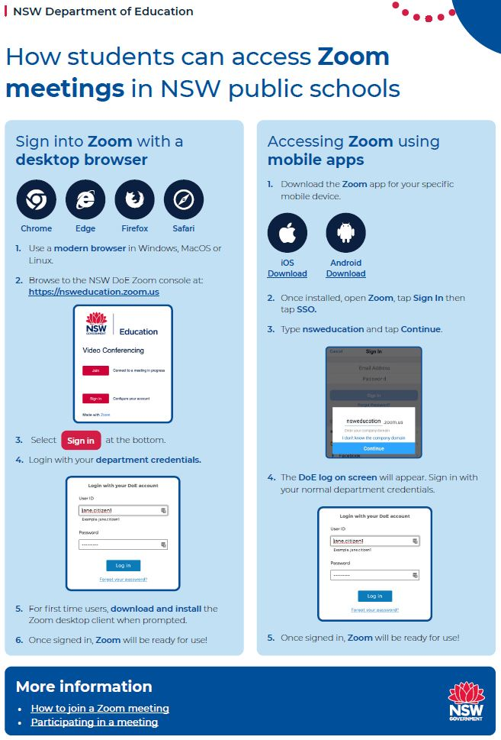

8. CCS Guide to Conferencing with Zoom
Teachers will be using the Zoom platform to conduct video conferencing. The DoE has set up Zoom for all students and staff via a DoE account. You MUST USE the NSW DoE Zoom Console to access Zoom.
- Type https://nsweducation.zoom.us/ into your browser

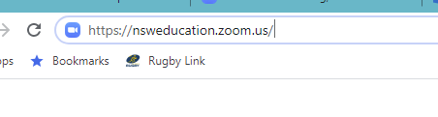
- The DoE Zoom console will open. Click on ‘Sign in’
- Your normal DoE Login will appear. Log in as normal
- Your DoE Zoom Account will open
- Click on ‘Join a meeting’ on the tab in the top right hand corner
- Type in the Meeting ID provided by your teacher then Join
- Follow all prompts from here.
- You will be prompted for a password.
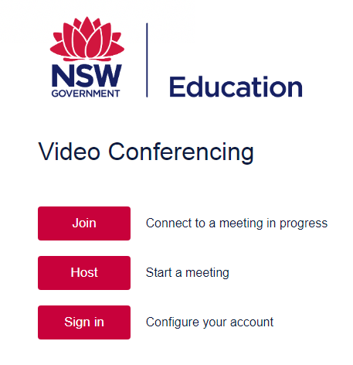

Click ‘Sign in’

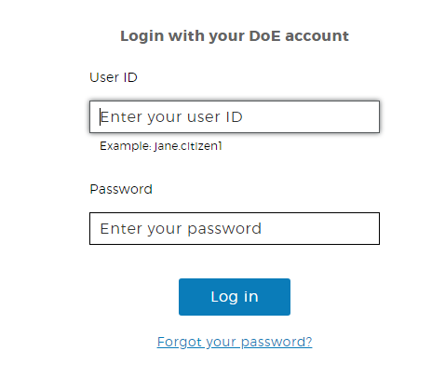

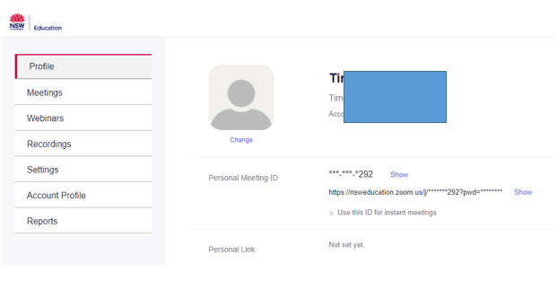

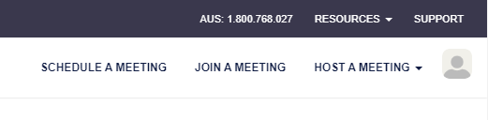

Click ‘Join a meeting’

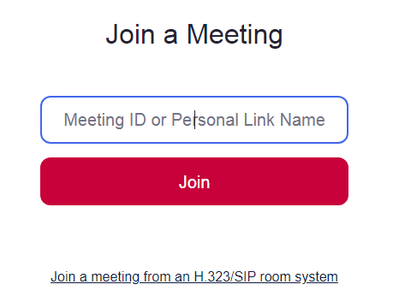

Type in the Meeting ID

- CCS Etiquette when Conferencing with Zoom
Etiquette is the customary code of polite behaviour in society or among members of a particular profession or group of people. Therefore, at CCS we are setting some expected behaviours, or etiquette, that will apply when students are participating in a Zoom Conference.

When you are in a Zoom conference your teacher can easily see who is
in attendance AND everything else in the background in your house
SIT AT A TABLE READY TO MAKE NOTES!
SO!

When in a Zoom Conference
- Be polite and respectful
- Do not make any inappropriate comments
- Use the Meeting ID and password supplied by your teacher
- Sit at a table (not on your bed!) and be ready to take notes!
- Sit in a well-lit and quiet place
- Set up an appropriate space when connecting to your meeting
- Do not Zoom from your bedroom!
- Sit somewhere with a nice background and be careful what people can see in the background (no dirty undies lying around!)
- Enable video and audio
- Wear headphones with a microphone
- Mute audio when not speaking to reduce feedback noise.
- Turn off your audio until requested to turn it on
- Be careful of ‘Zoom bombers’ (that includes your little brother or older sister, and yes, your parents!)
- Ask questions using the group chat
- Keep the chat questions on the lesson topic
- Read carefully what you’ve typed before sending your message in chat.
- Keep the topic of the Zoom Conference on schoolwork
- Use the raise your hand feature if wanting to ask a question
- Dress appropriately! No pyjamas!

PARENTS
Our time with students is important. Please don’t ‘hover’ around a Zoom conference and please do not ask to speak with a teacher after a Zoom conference in the Zoom room.
Contact the school if you have any questions……………Yes, it has happened!
10. Signing in to Seesaw
Teachers choose whether students sign in to Seesaw by scanning a Student Code or logging in with their Email /
Google Account.
Student Code - Shared Device and 1:1 Sign In
Designed for young learners (K-2) and shared devices. No usernames/passwords are required. Students sign in using the QR Student Code or Text Student Code. Students choose their name from the class list to add items to their journal.
- Go to the Seesaw Class app or app.seesaw.me
- Tap “I’m a student”.
- Tap the blue “scan code” button and scan the QR code for the class OR type in letters to access your account (this will be provided to students by the school)
- 1:1 students choose their name from the list, shared device students are ready to make a post!
Example only
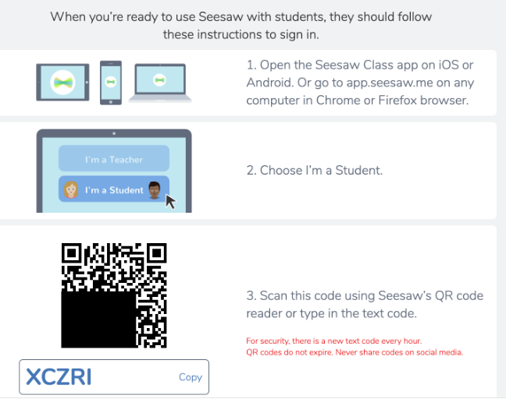

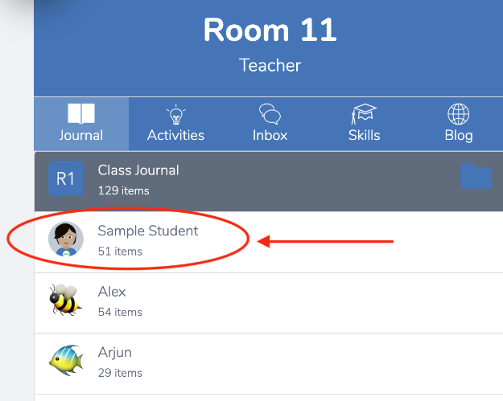

Email or Google Account Sign In
Designed for students who can remember their email address and password. Students type in a Student Code to join the class for the first time. Afterwards, they just need to use their email/password to sign in to Seesaw.
- Open the Seesaw Class app
- Tap “I’m a student”.
- Input the Class Join code from the teacher and tap “Go”
- Tap “Sign in with Google” if students are signing in with a Google account or enter name, email and password and tap “create account”.

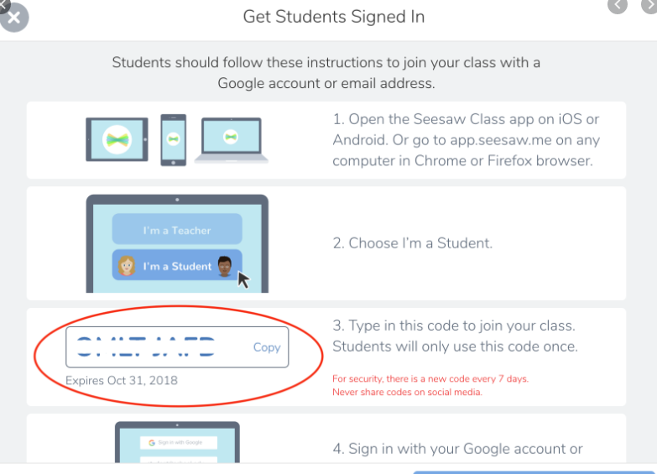

Once signed in, a student will stay signed in for up to one year until they sign out. If a student code is compromised, teachers can reset the code for the student or the entire class.

12. Example of K-2 Student Login Details to Seesaw
Students in K/1 and Year 2 will receive a laminated sheet like this to enable them to login to Seesaw using the QR code scanner functions. Each sheet will feature the students name and include a QR code account letters to access Seesaw. Please keep this safe , it’s like a password to your Seesaw Class!
